**Github Repository Link:-** https://github.com/Kesavanagendra/JMeter_LessonEnd_Project.git

**Evaluate the Performance of an E-learning Application Using Jmeter**

By using Blaze Meter Extension Recorded the Scripts on the Simplilearn website.

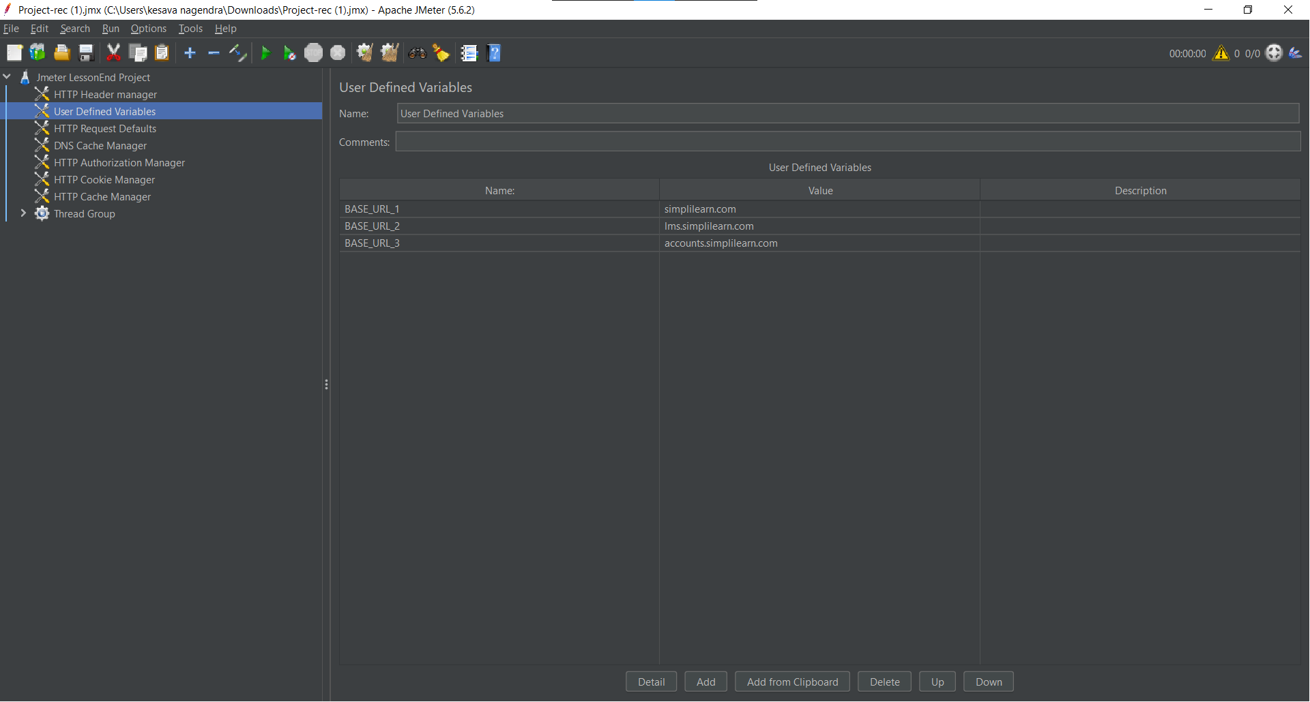

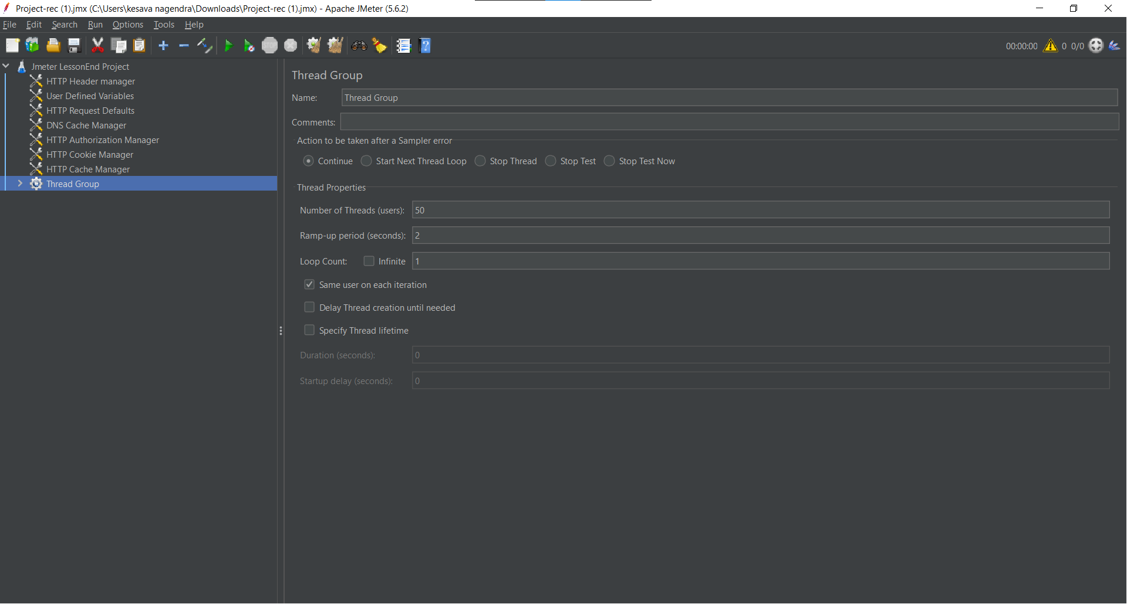

In the Thread Group added the Three simple controllers.

Right click on Thread Group->Add->Logic controller->Simple Controller

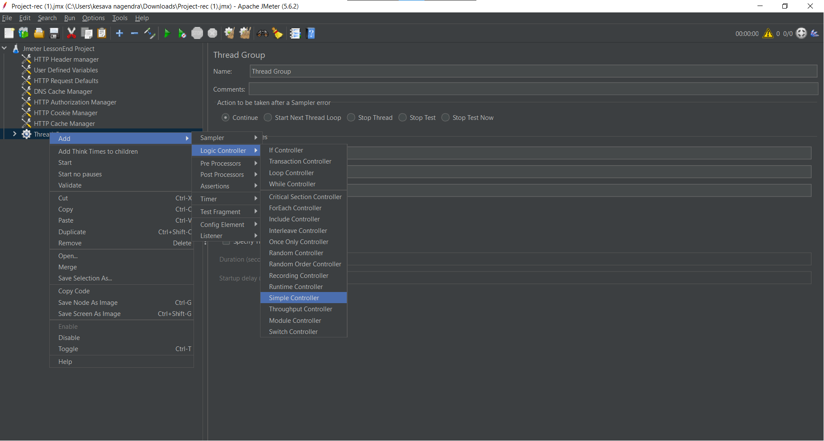

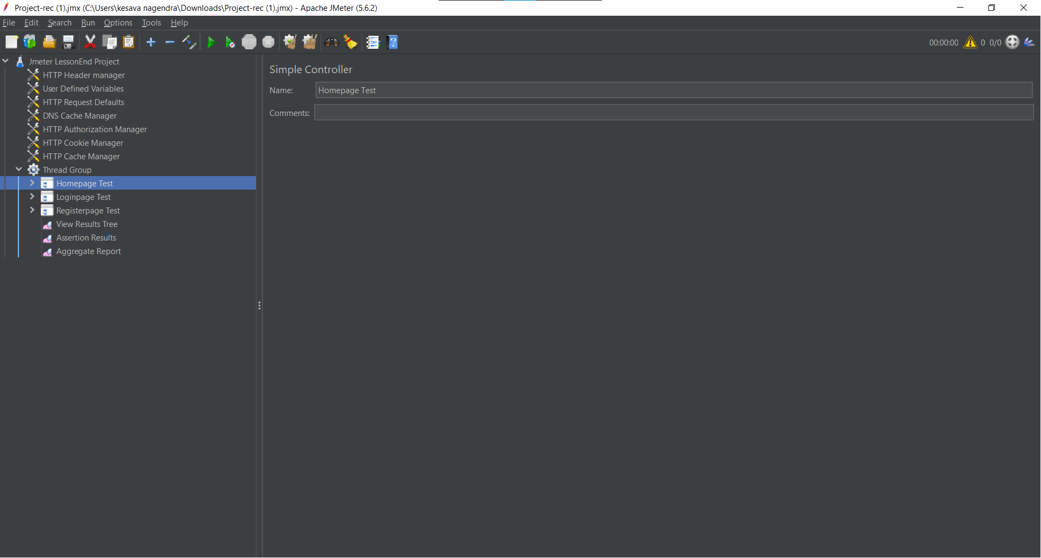

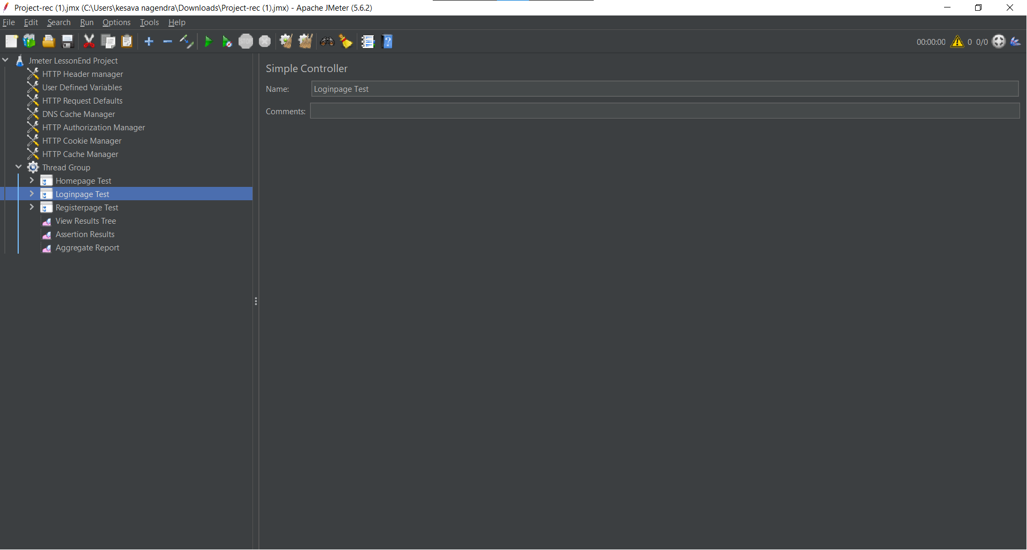

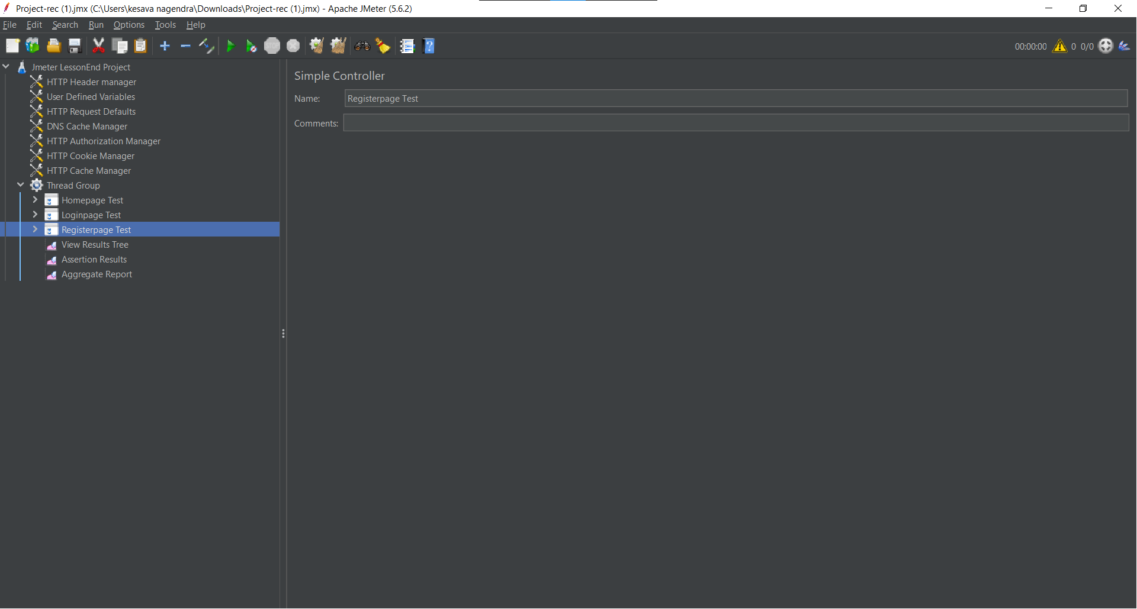

In the Three simple controllers organized the samples as shown below.

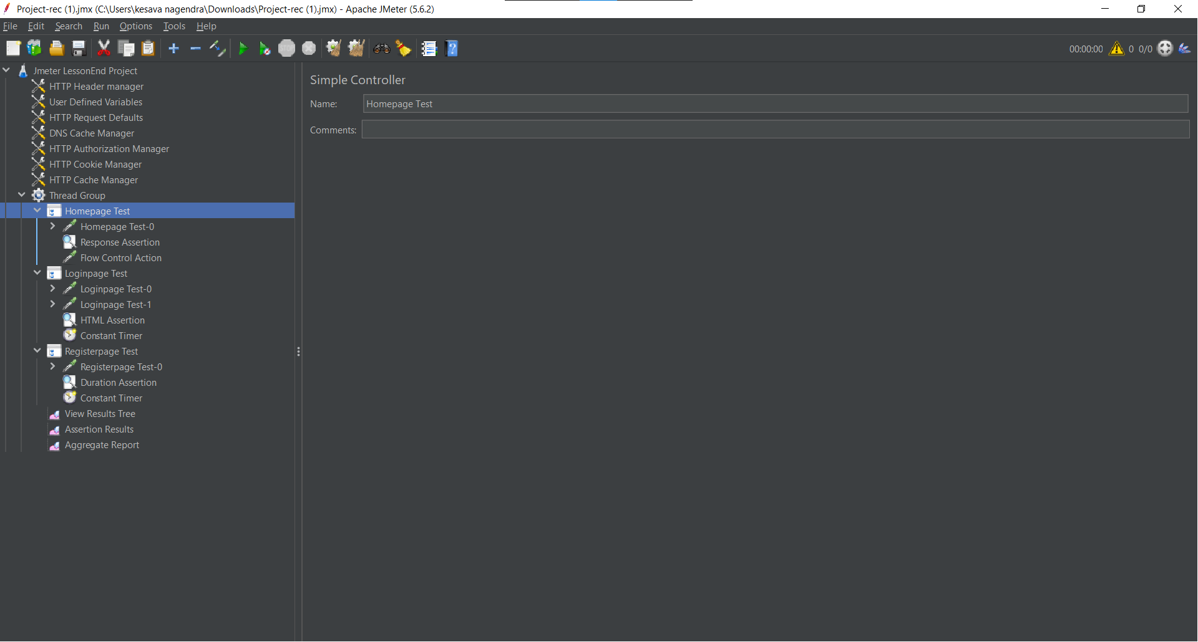

And Applied the Naming policy on samplers.

Right click on simple controller ->Apply Naming Policy

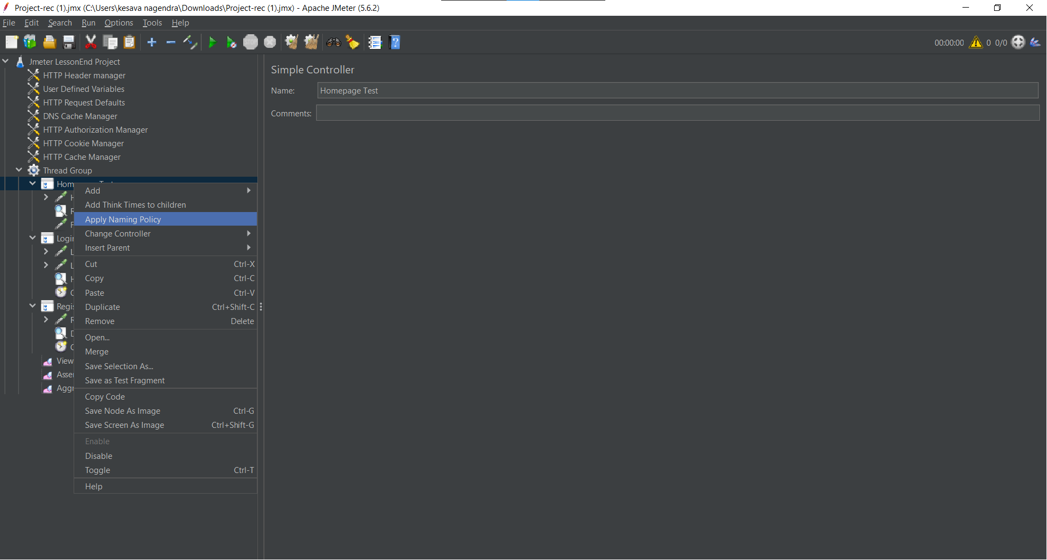

In the Homepage Test Simple controller added the Response Assertion.

Right click on Homepage Test controller->Add->Assertions->Response Assertion.

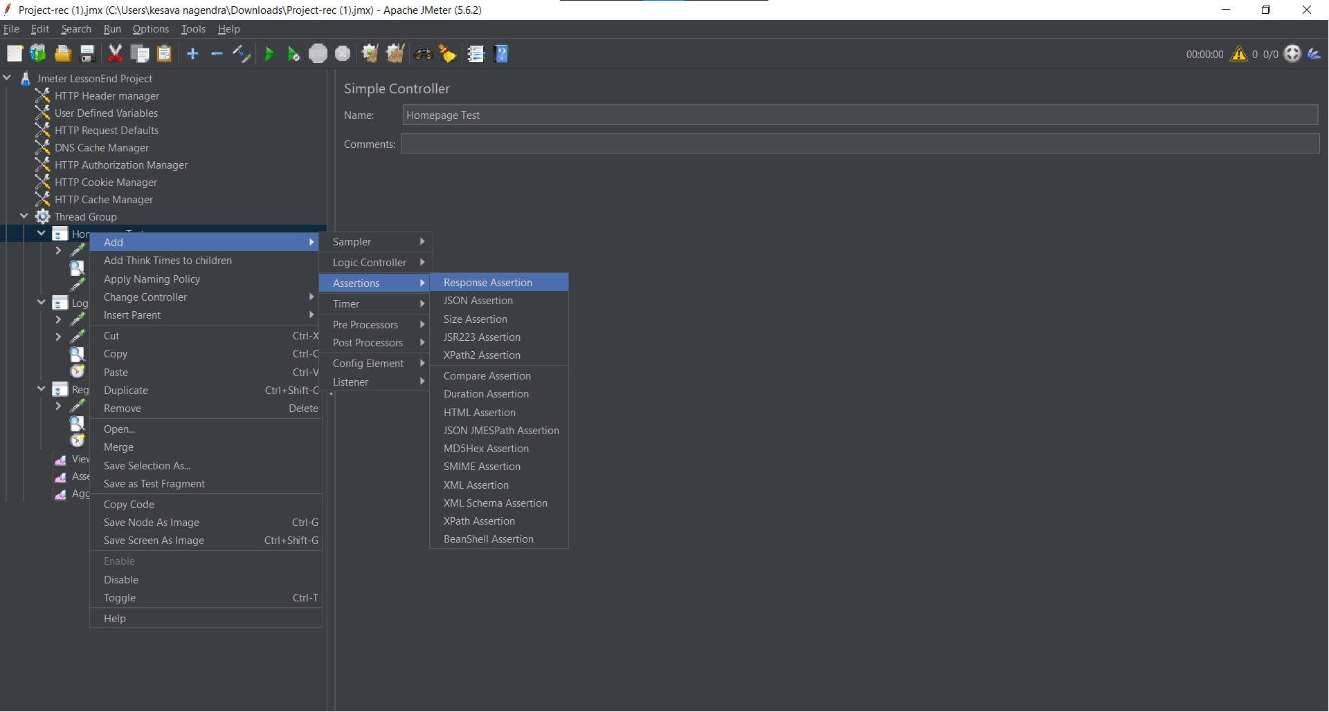

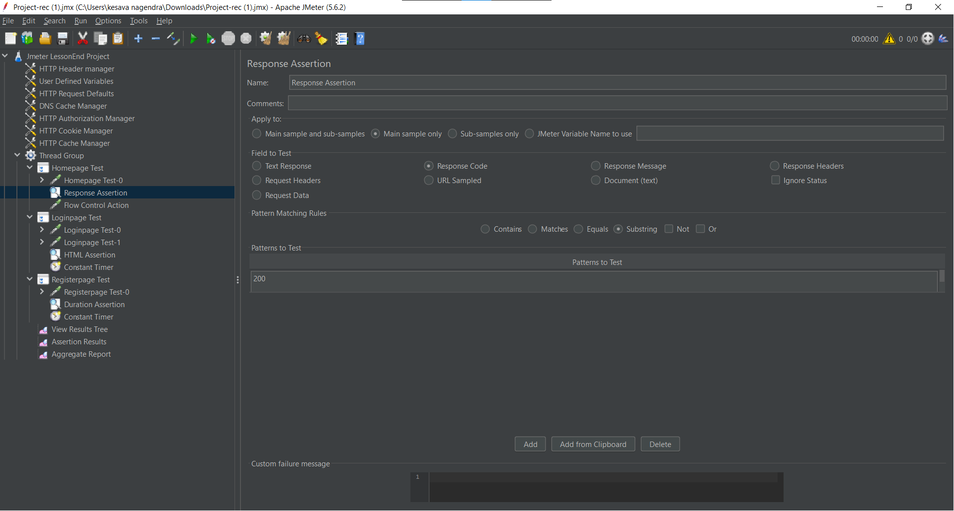

Again In the same Homepage Test Simple controller added the Flow control Action.

Right click on Homepage Test controller->Add->Sampler->Flow control Action

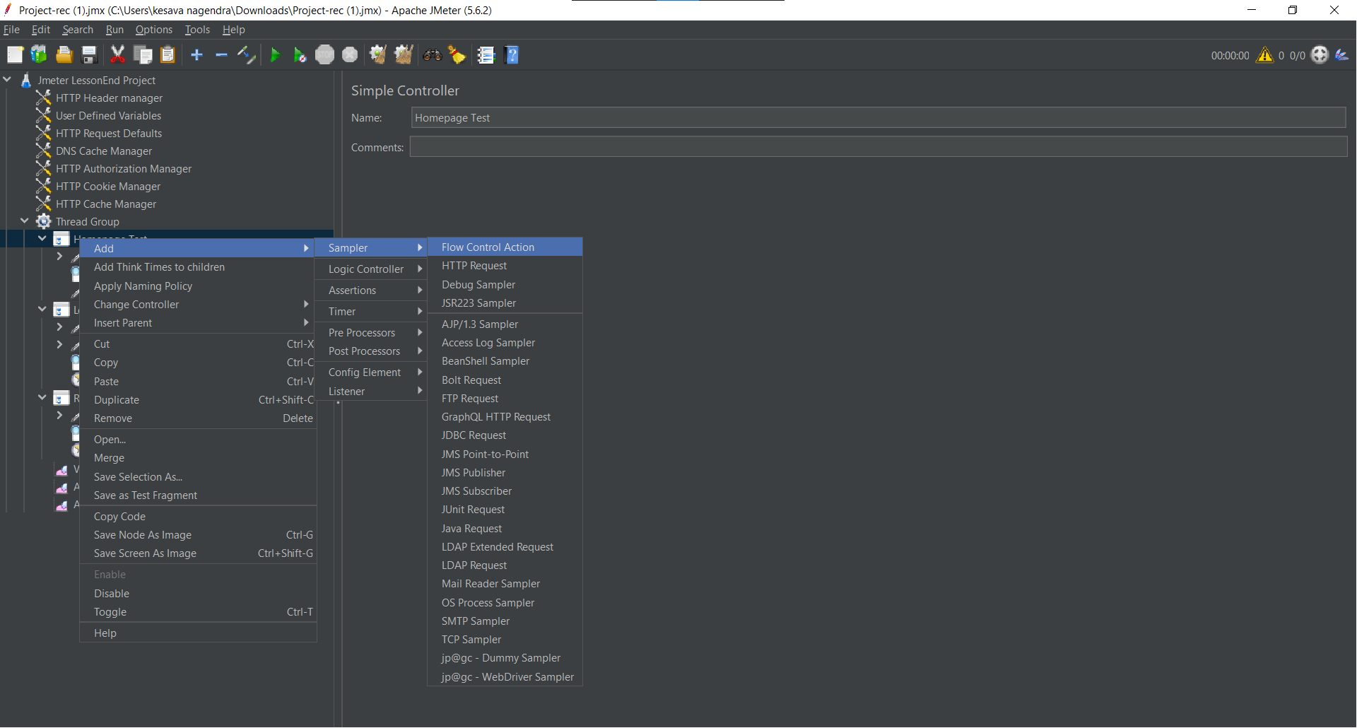

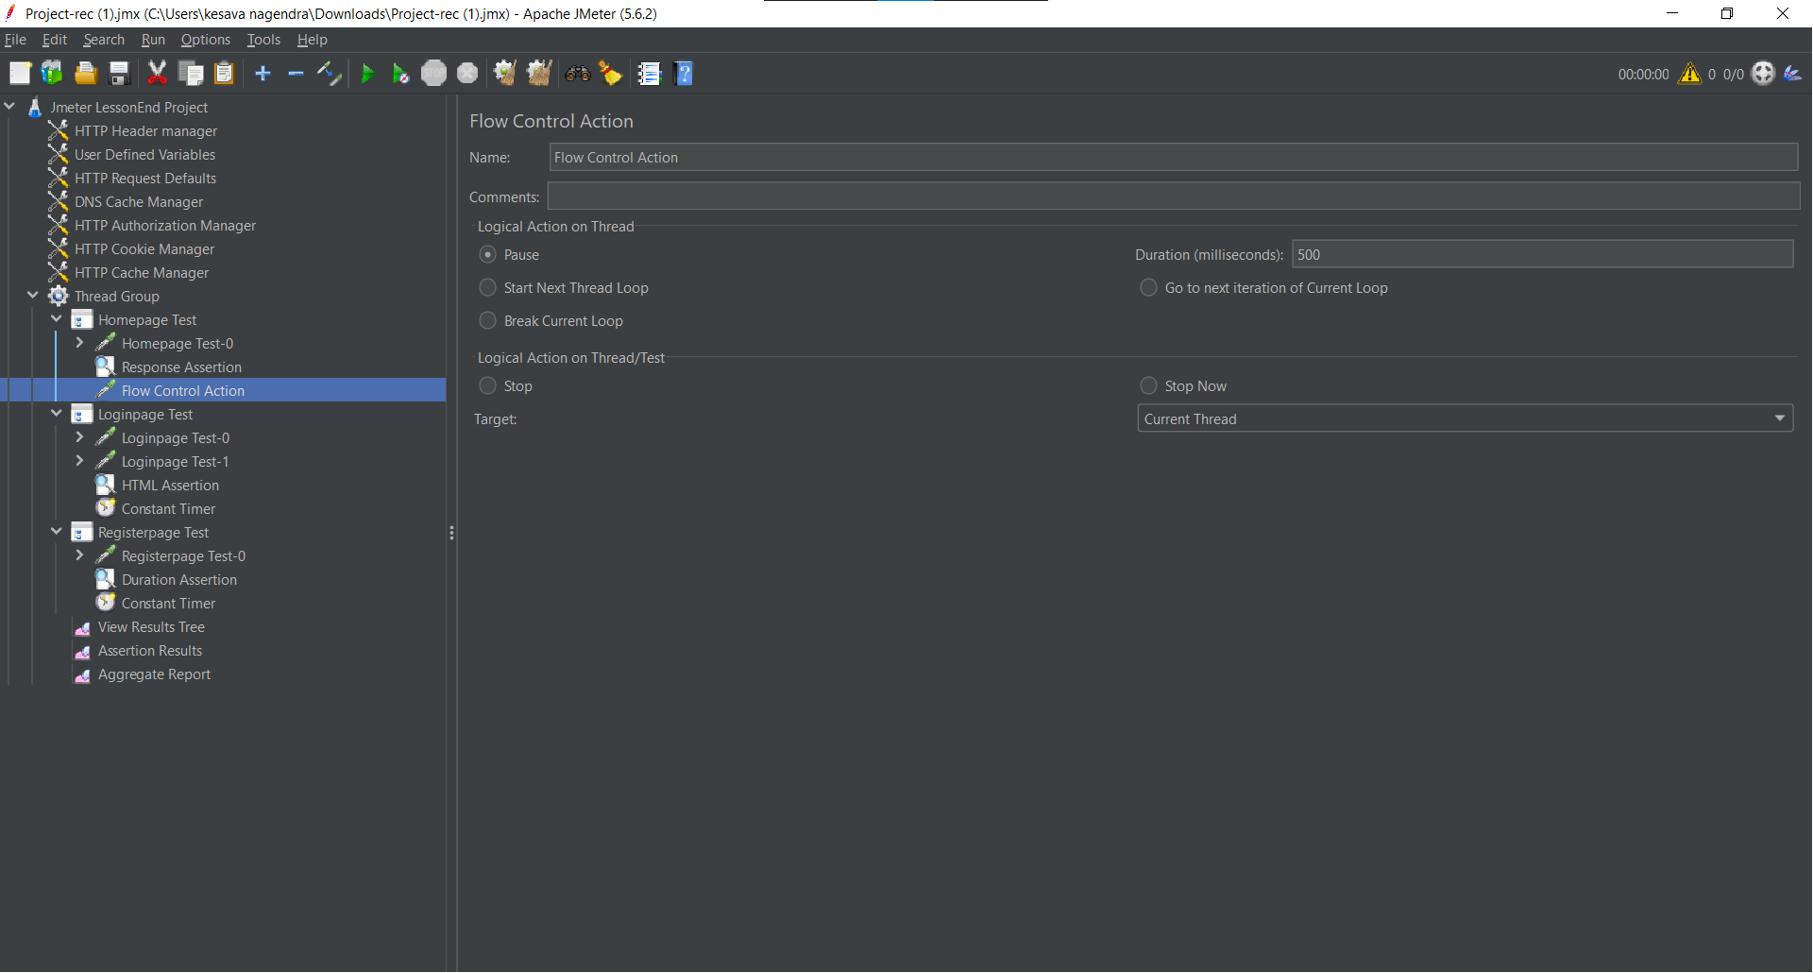

Again In the same Homepage Test Simple controller added the Constant Timer

Right click on Homepage Test controller->Add->Timer -> Constant Timer

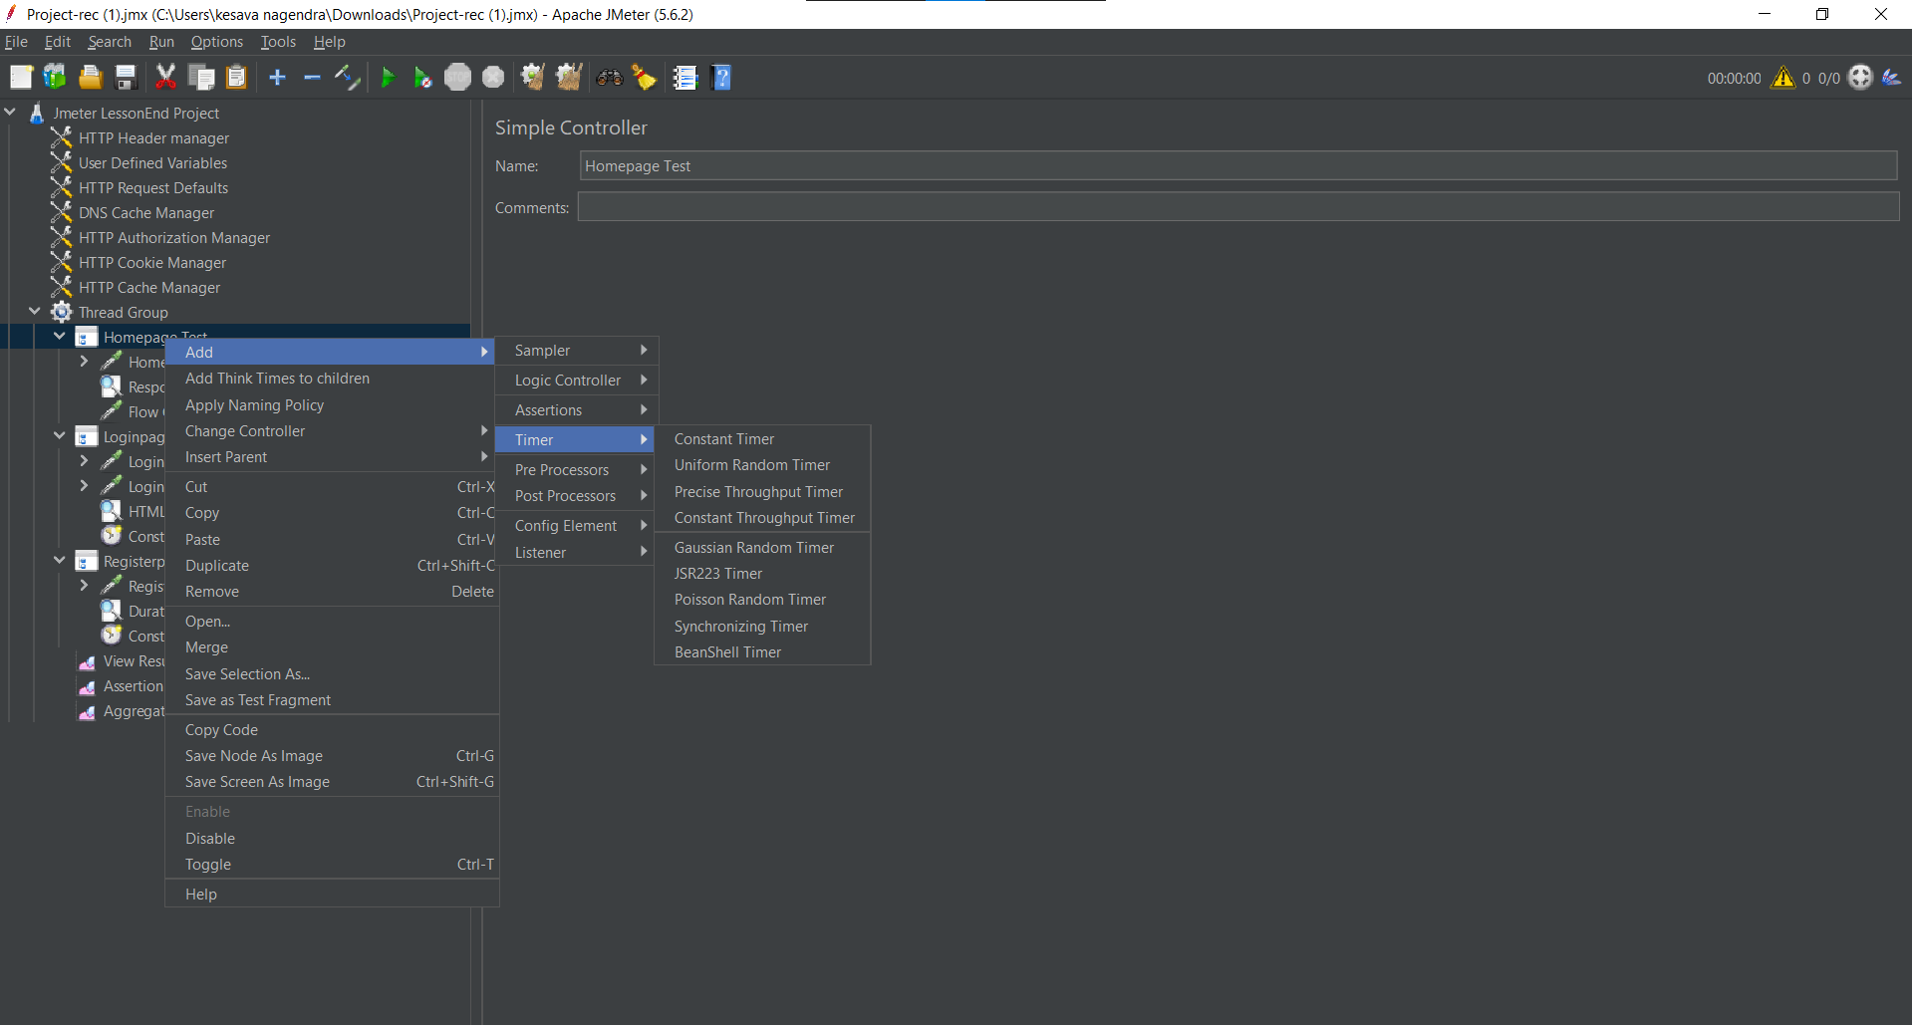

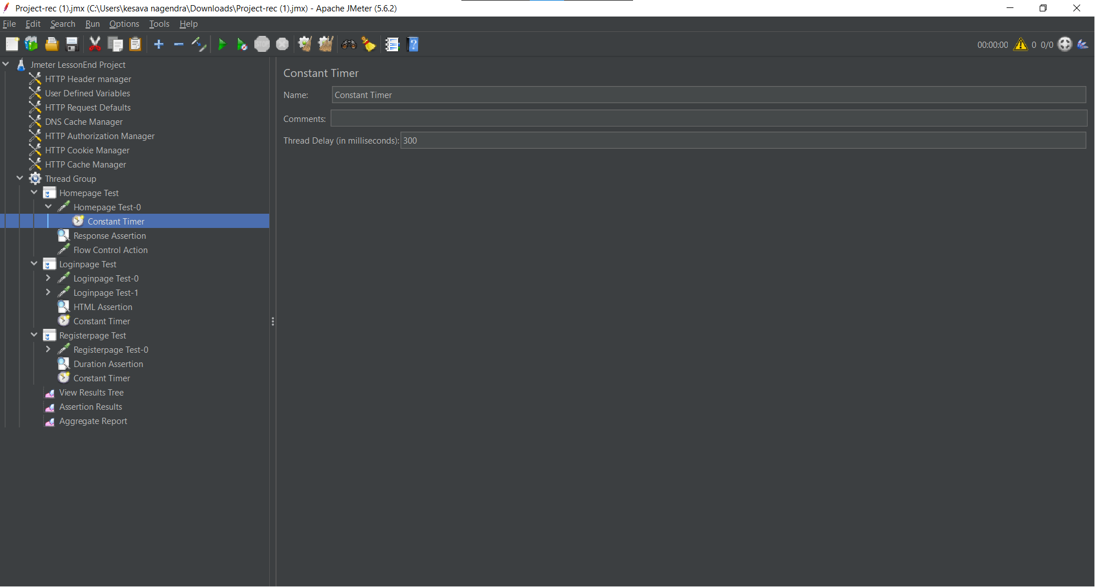

In the Loginpage Test Simple controller added the HTML Assertion.

Right click on Loginpage Test controller->Add->Assertions->HTML Assertion.

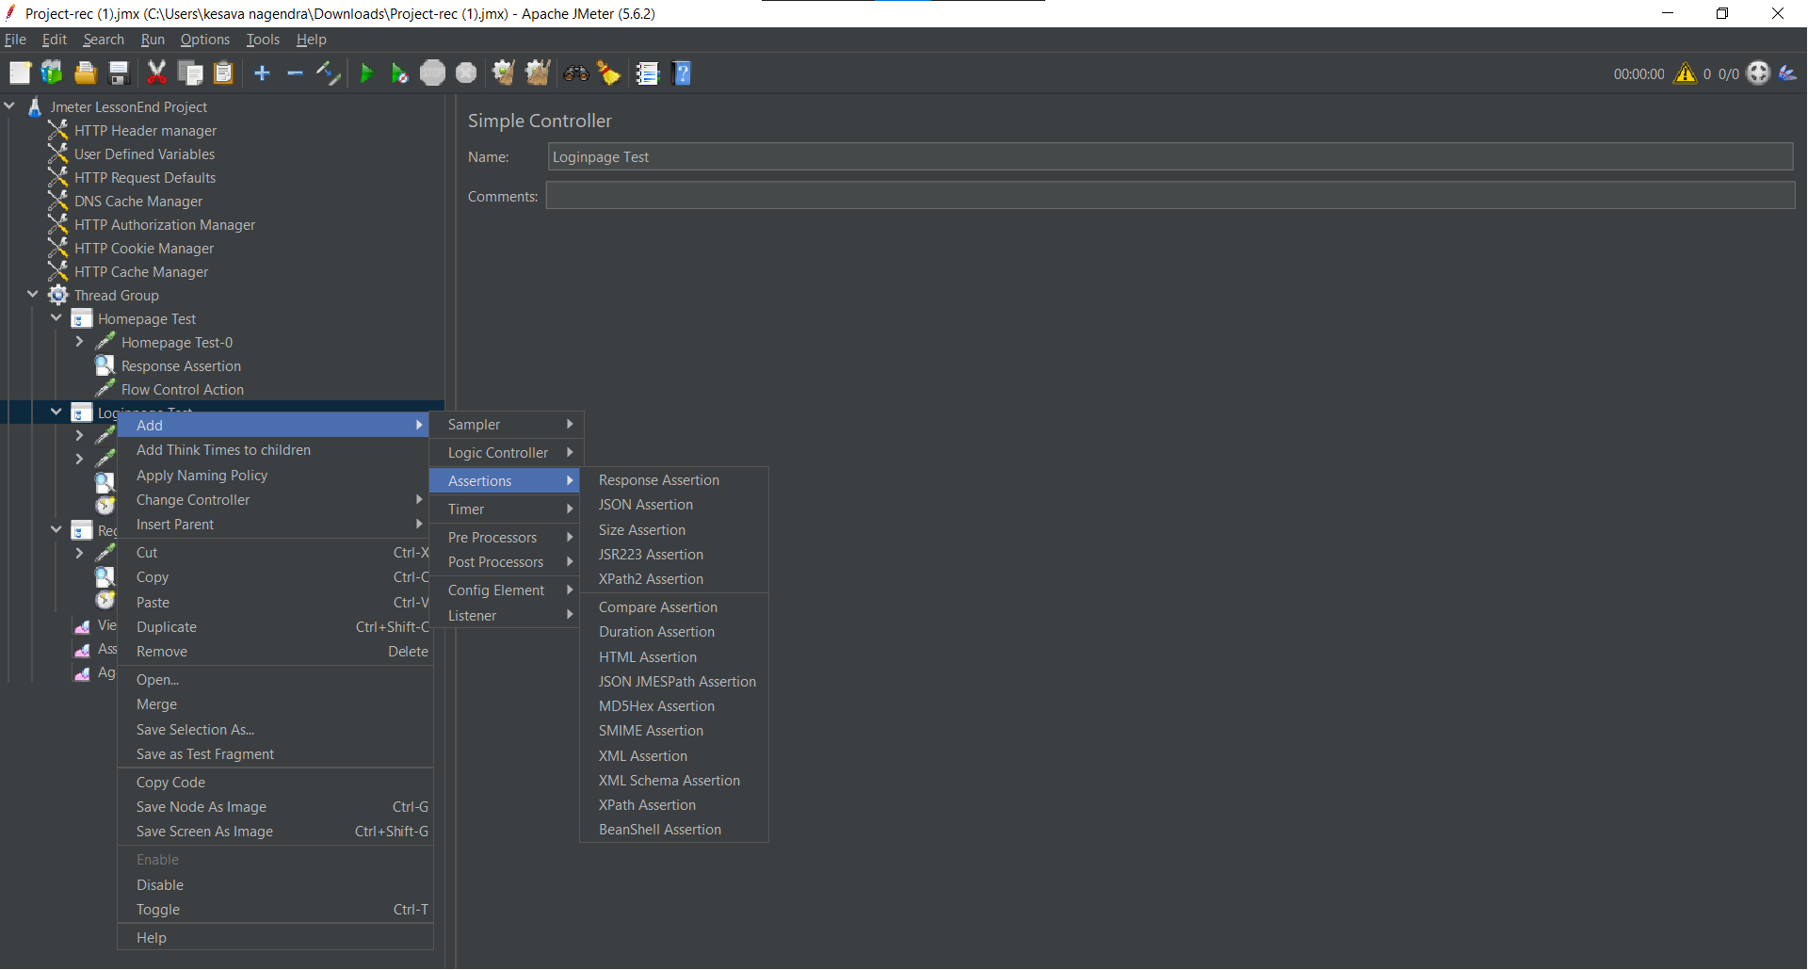

Given the path location with file name.txt extension for store and display the errors and warnings those are present on the given https link.

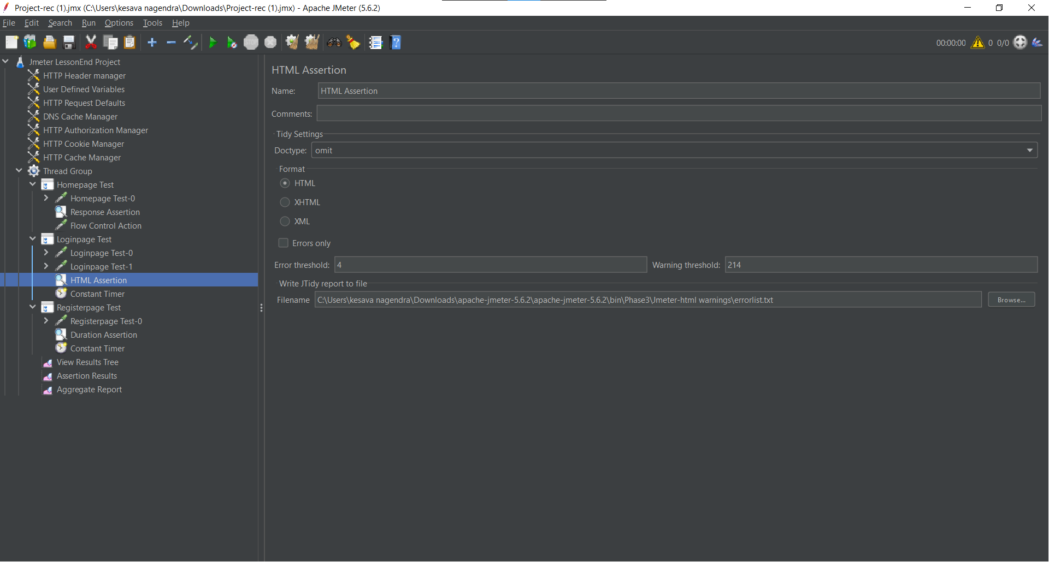

Again In the same Loginpage Test Simple controller added the Constant Timer

Right click on Loginpage Test controller->Add->Timer -> Constant Timer

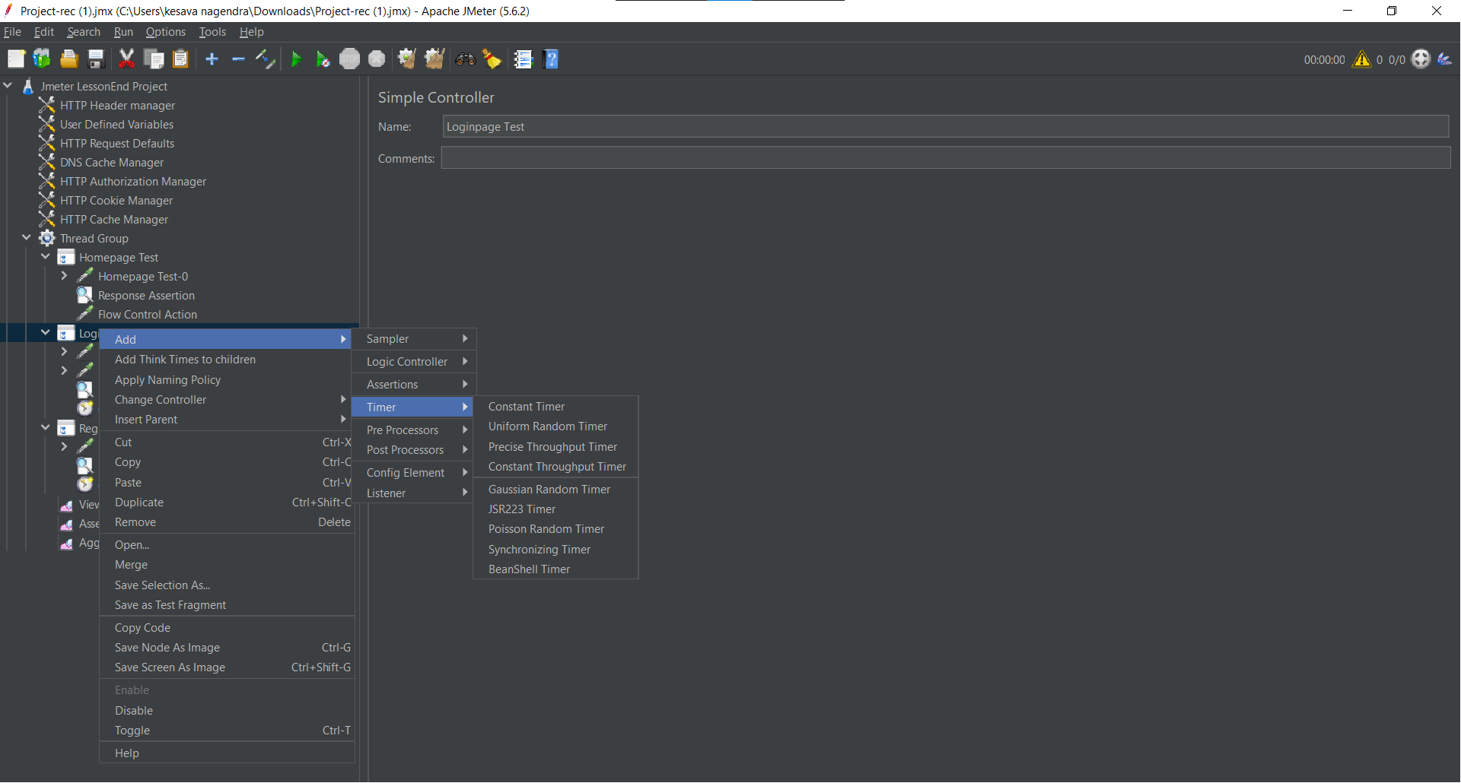

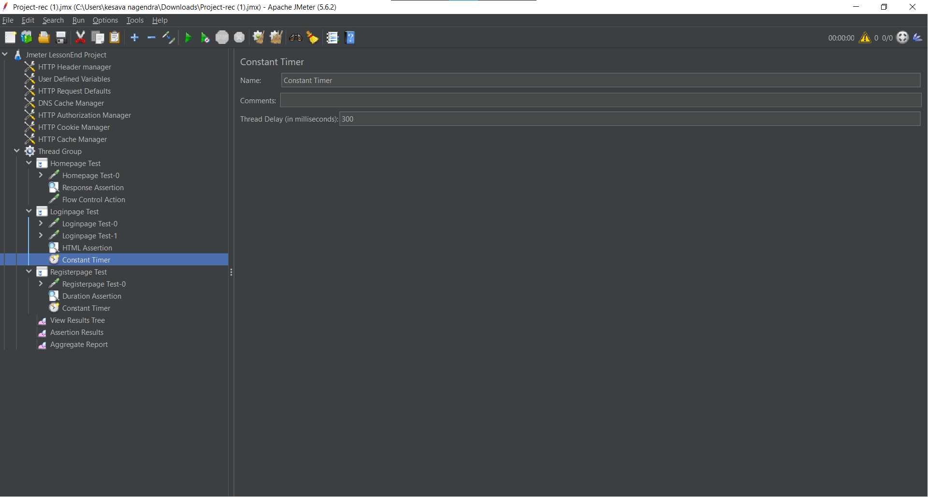

In the Registerpage Test Simple controller added the Duration Assertion.

Right click on Registerpage Test controller->Add->Assertions-> Duration Assertion.



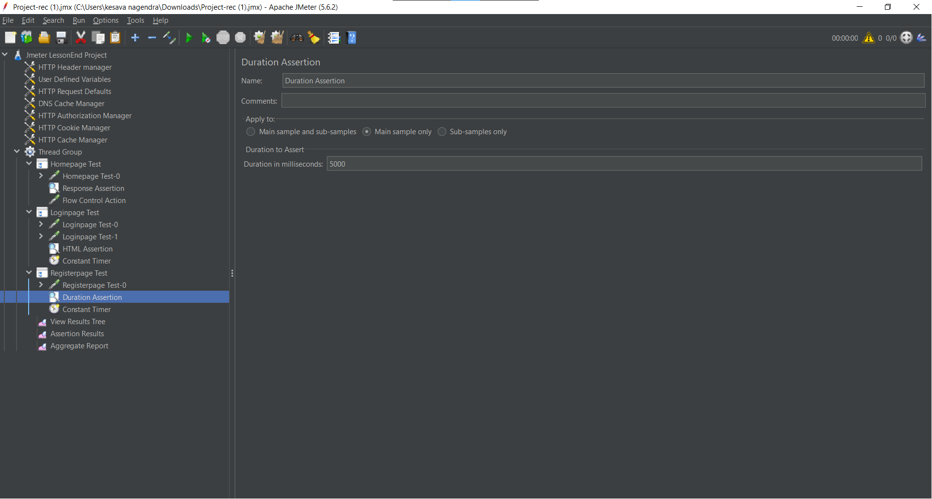

Again In the same Registerpage Test Simple controller added the Constant Timer

Right click on Registerpage Test controller->Add->Timer -> Constant Timer

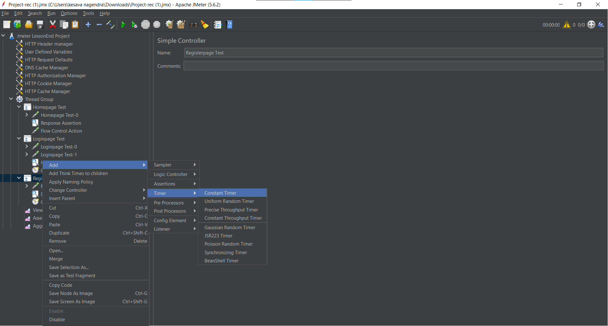

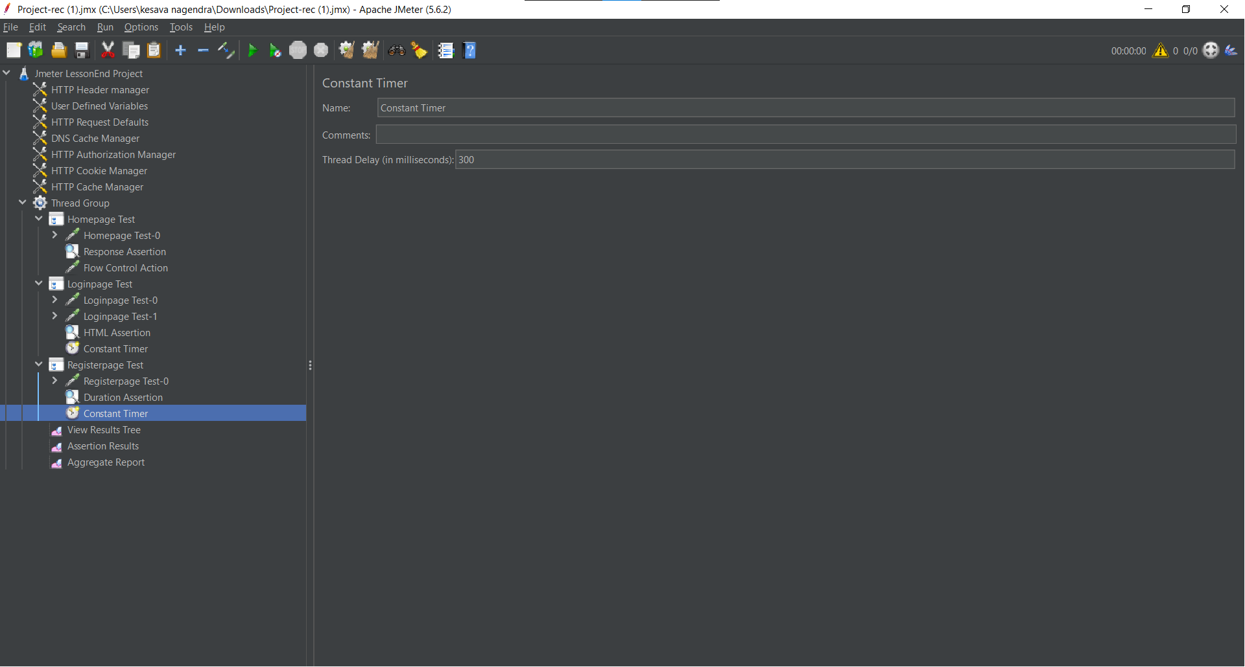

In the Thread Group, Existed Homepage Test simple controller changing into Loop controller.

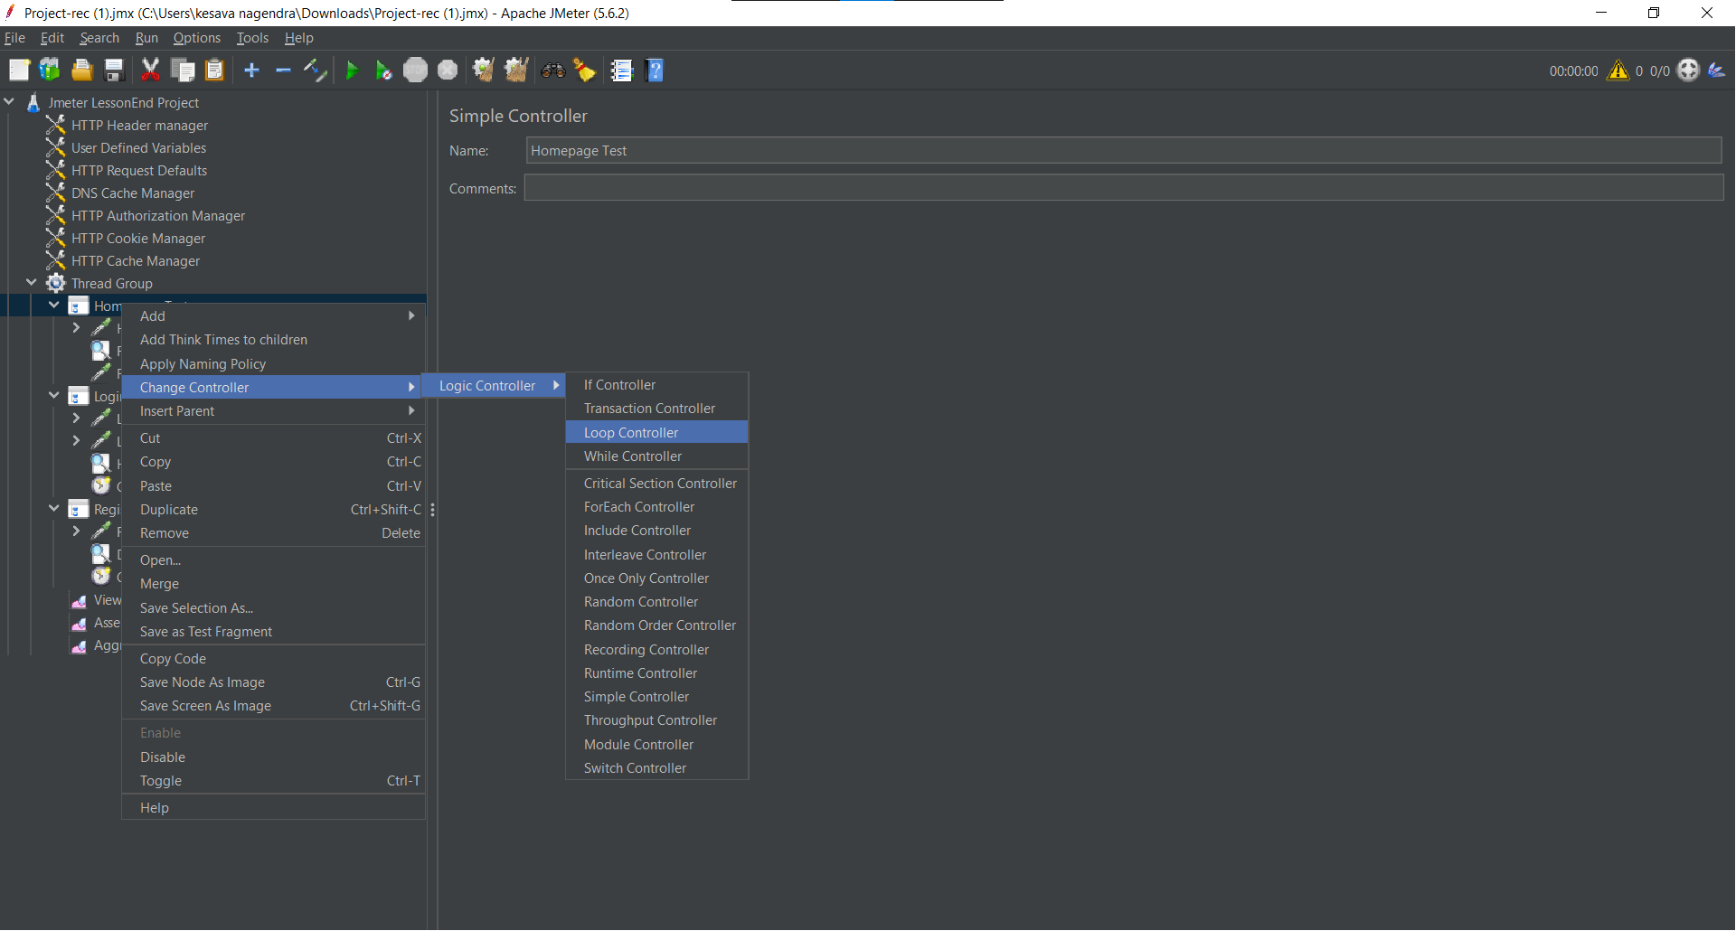

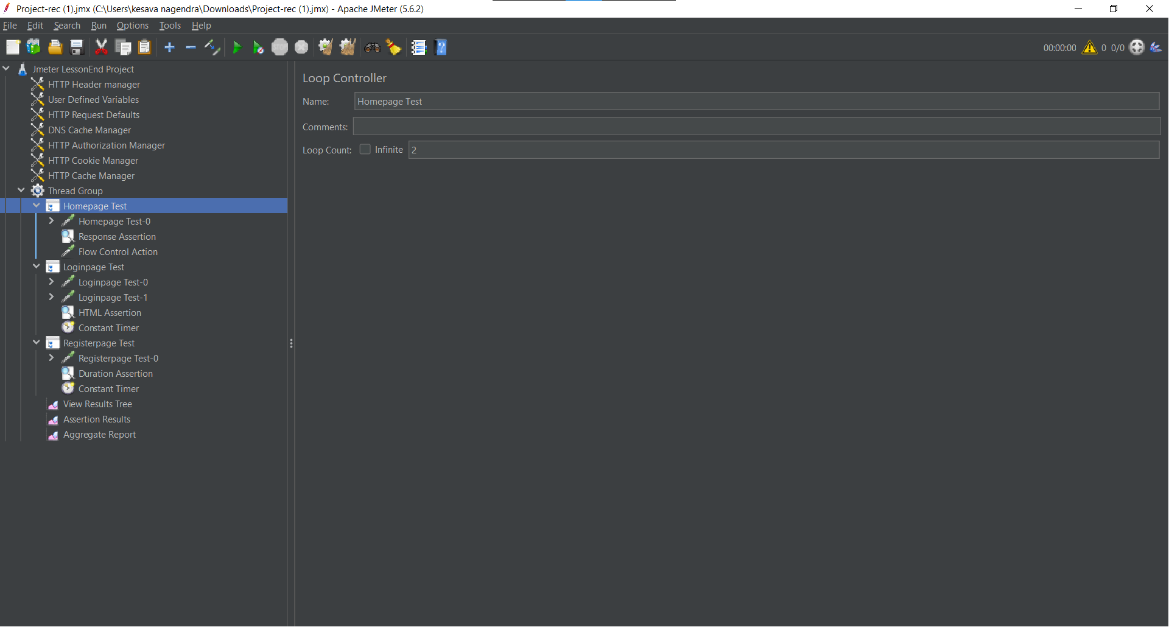

In the Thread Group added the Listeners View Result Tree , Aggregate Report and Assertion Results.

By Right click on Thread Group->Add->Listener-> View Result Tree

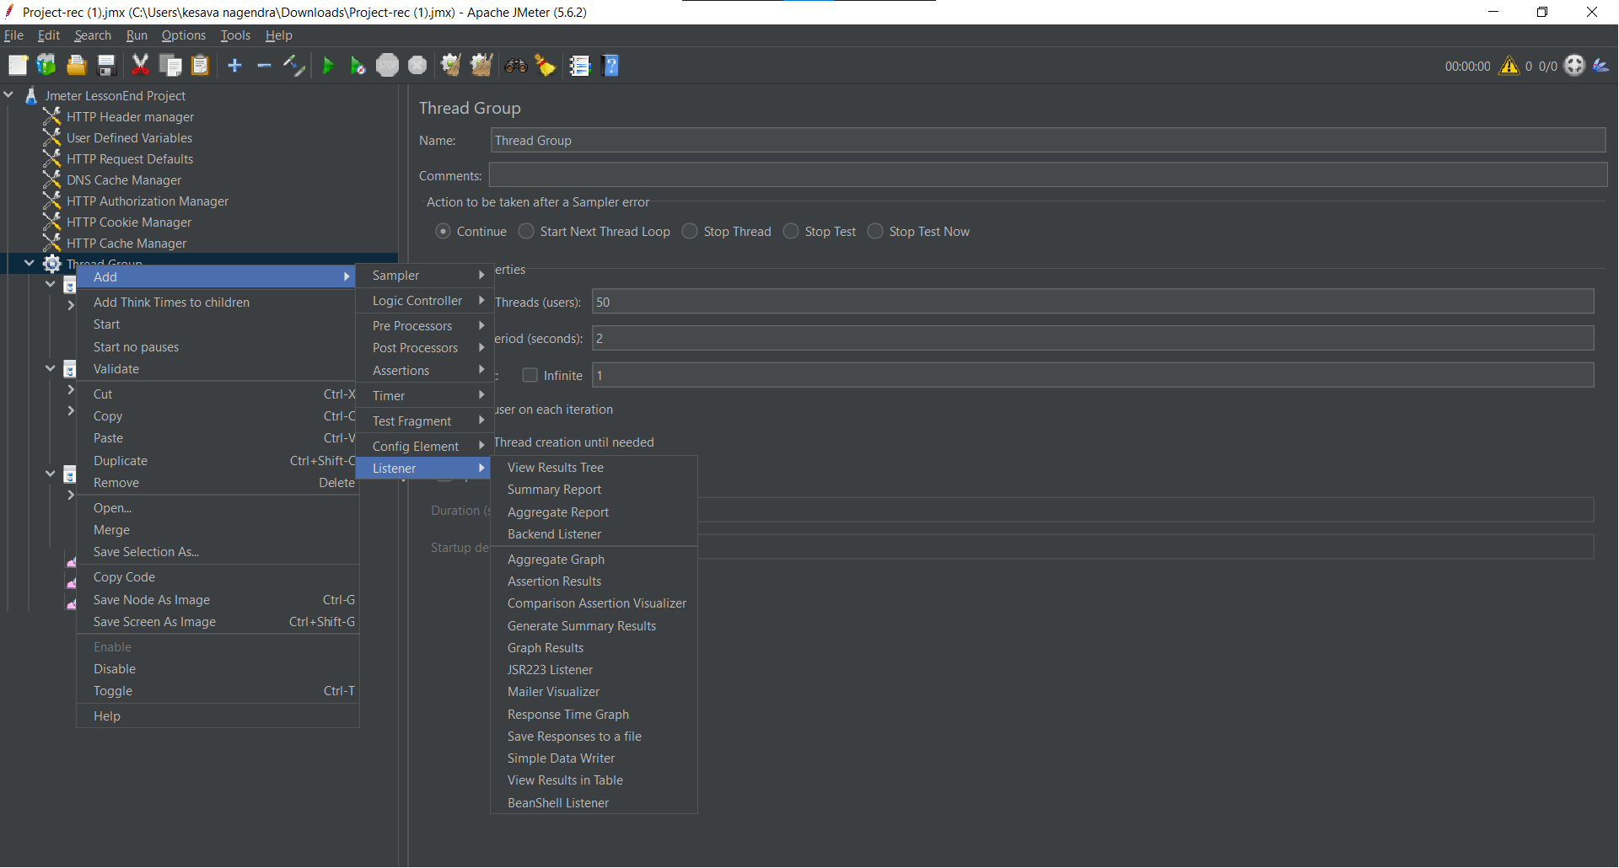

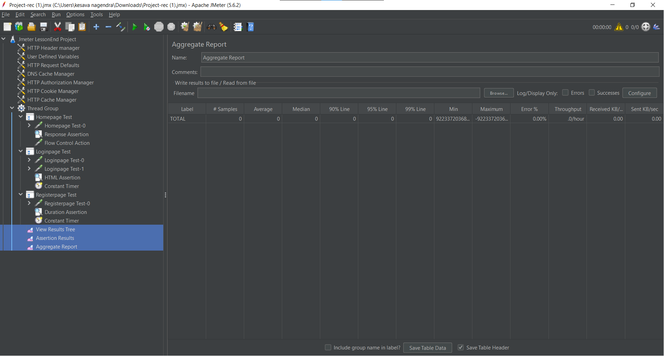

**Output view in View Result Tree**

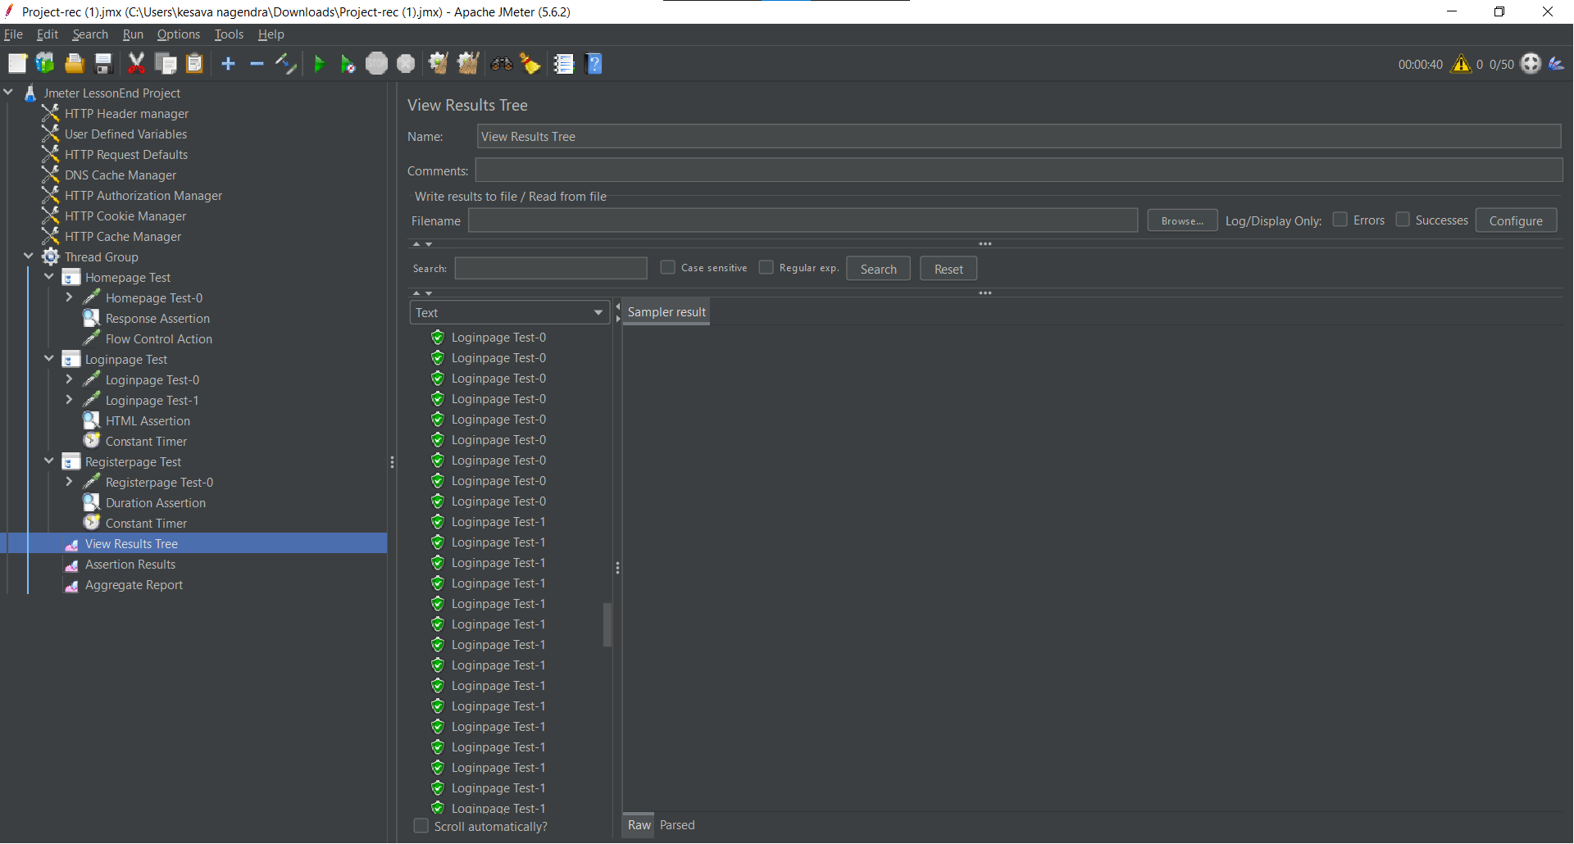

**Output view in Assertion Result**

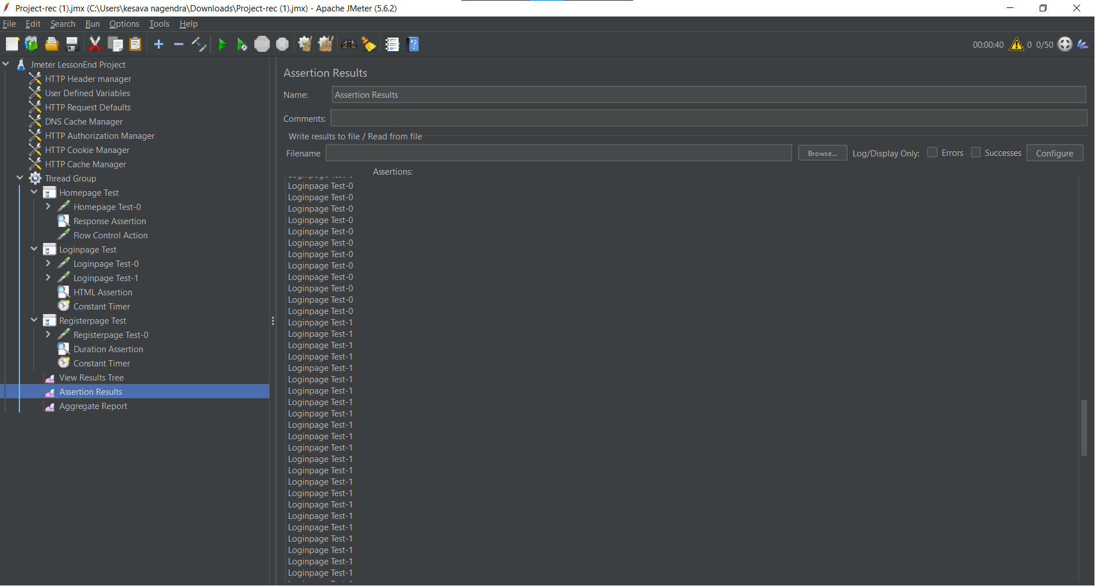

**Output view in Aggregate Report**

